Introduction
Buddhism arrived in Japan beginning in the 6th century. Various types of Buddhism entered Japan, in successive waves, from China and Korea. In Japan, Buddhism has co-existed (and continues to co-exist) with Shinto, a religion that predates Buddhism and revolves around the worship of nature deities (kami, 神). Religious adherence/religious identity is a complex phenomenon in contemporary Japan. For example, people who identify as “nonreligious” (mushūkyō, 無宗教) in surveys, may mean that they do not belong to any organization, although they may take part in certain religious rituals (perhaps even regularly). However, when required by a survey to select a religious tradition, many respondents will select both Buddhism and Shinto. This is evidenced by the following 2015 survey data from Statistics Japan:
- Shinto: 89,526,000
- Buddhism: 88,719,000
- Christianity: 1,928,000
- Other: 8,719,000
  - These numbers exceed the entire population of Japan (127.1 million in 2015).
1. Pureland Buddhism / Jōdo Bukkyō (浄土仏教)
- Arrived during the Kamakura period (1185-1333)
1.1 The Pure Land School / Jōdo-shū (浄土宗)
- Established in 1175 by Hōnen (法然, 1133 –1212), an ex-Tendai monk (see below on Tendai Buddhism).
- It is the most widely practiced branch of Buddhism in Japan together with Jōdo Shinshū (see below).
- This school and subsequent Pure Land schools are based on (late) Indian and Chinese Buddhist notions of a “Pure Land” (Jōdo, 浄土) of Ultimate Bliss (Gokuraku, 極楽), which was constructed by the merit and compassion of Amida Buddha (阿弥陀仏, known as Amitābha in Sanskrit). We already studied this in conjunction with Indian and Chinese Buddhism.
- As a quick reminder: According to Pure Land scriptures, Amitābha/Amida Buddha vowed to save beings by bringing them to the Pure Land after death. In the Pure Land, beings would then become awakened / attain nirvana through learning (completely unpolluted) dharma from enlightened Buddhas.
- Hōnen proposed that salvation could be achieved simply through Amida’s name. He wrote that “even the most unworthy will achieve rebirth in the Pure Land of Amitābha (Amida) by relying on the power of Amitābha's vow to save all beings who call upon his name” (Keown, A Dictionary of Buddhism, p. 129).
  - In this way, Hōnen was heavily influenced by the thought of Chinese Pure Land scholar/master Shandao (善导大师/善導大師), 613-681 CE (See Part 8: Buddhism in China).
- Hōnen taught that one need only to perform this practice of calling the name of Amida to assure rebirth in his Pure Land. Hōnen asserted the practice of chanting the name of Buddha Amida (the chant known as the nenbutsu, 念仏) would be conducive to rebirth in the Pure Land and eventual attainment of Buddhahood / nirvana.
  - The chant is pronounced like this: namu amida butsu (南無阿弥陀仏), which is a translation of the Sanskrit नमोऽमिताभाय (namo'mitābhāya), which means, “Homage to Amida/Amitābha Buddha.”
- Hōnen asserted that in the time of the decline of the teachings (mappō, 末法), people could not possibly effect their own liberation on the basis of their “self-power,” e.g., meditation/study. They needed to rely on the “other power” of Amida.
  - Here's the entry from A Dictionary of Buddhism on the concept of mappō:
    - "Japanese term meaning ‘the end of the Dharma’. During the medieval period in Chinese Buddhism (see China), the Buddhist community came to accept that the history of Buddhism would be divided into three periods: that of the True Dharma, that of the Counterfeit Dharma, and that of the End of the Dharma. During the first, which would last 500 years, the teachings of the Buddha would be transmitted with minimal distortion, and beings had a good chance of understanding and practising them, and of achieving enlightenment (bodhi). During the second period, also 500 years, the substance would be gone and only the outer forms of practice would remain. Fewer beings would attain the goal at this time. During the third period, even the semblance of genuine practice would disappear, and beings would be left to their own devices. According to most calculations of the time of the Buddha's death, the world was already in the period of mappō. While this may appear to be cause for despair, many in east Asia actually responded to this analysis not by giving up, but by advocating new and creative doctrines. In response to mappō, new schools arose, such as the Pure Land and Nichiren schools, asserting that the Buddha had foreseen and provided for the advent of this final age by preparing texts and teachings suited for beings born in this time. These teachings had been discovered and propagated to counter the adverse conditions of mappō and give beings hope for liberation. This assertion validated texts, teachings, and practices that obviously conflicted with what was known of early Buddhism by arguing that the difference between the first period of the True Dharma and the present period made it necessary that the teachings be significantly different. It was felt that the degenerate conditions of the present age demanded it. See also shō-zō-matsu; three periods of the teachings."
Kōtoku-in (高徳院) is a famous Pure Land Buddhist Temple in Japan
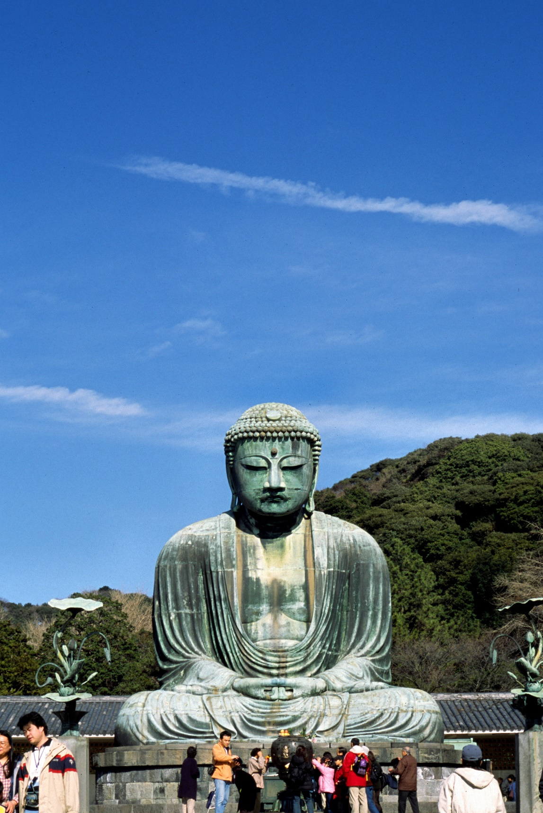
I took this picture on my first trip to Japan in 2000!
- The temple is renowned for its its “Great Buddha” (大仏), a huge (13 meter) bronze statue of Amida Buddha, which dates from about 1252 C.E.
- The statue is hollow and visitors can enter and view the interior. (Many visitors have left graffiti on the inside of the statue.)
- The statue is a typical example of the style of Kamakura period Buddhist sculpture. See http://www.kotoku-in.jp/en/about/characteristic.html for a full description of the statue’s iconography.
  - This Buddha’s hand gesture (Sanskrit: mudra) is called “upper, upper birth” (jōbon jōshō 上品上生). This is a raigō-in (来迎印) or "welcoming mudra." Amida uses nine different welcoming mudras when welcoming the dead into his Pure Land. Amida’s Pure Land is composed of nine different levels and the dead (who are successful in getting into the Pure Land) are reborn into one of them. Therefore, in the Pure Land, people have a status linked to their level of spiritual advancement.
  - All Buddhas have 32 physical characteristics that distinguish them as Buddhas. One of these characteristics is known as the byakugō (白毫; Sanskrit: ūrṇā), a swirl of clockwise-curled hair between the eyebrows.
  - Read the following passage on other aspects of standard Amida Buddha iconography: "Other distinguishing features of the Amida Buddha are the extended lobe on top of his head to accommodate his advanced understanding of the truth. His large ears that allow him to hear all people in need. the rose coloured crystal set amongst his curly hair that emit rays of light to display his supreme knowledge. A single white spiral of hair on his forehead indicated by a white crystal to show his love and affection for humanity and the folds on his neck that indicate compassion to all people" (source: https://www.ngv.vic.gov.au/explore/collection/work/96051/).
- Until the twelfth century Amida Buddha was typically portrayed in a seated position (on a lotus flower). During the Heian period (794–1185) and Kamakura period (1185–1333) the concept of raigō ("welcoming descent" or "welcoming approach") grew popular and Amida Buddha was often represented in a standing pose while he descended from the Pure Land through the sky (to welcome the dead). Here's an example of a raigō painting (dating to the 13th-14th centuries), in which Amida descends with his retinue of attendants to bring a deceased practitioner to the Pure Land. Check out the dead man seated in the bottom right!
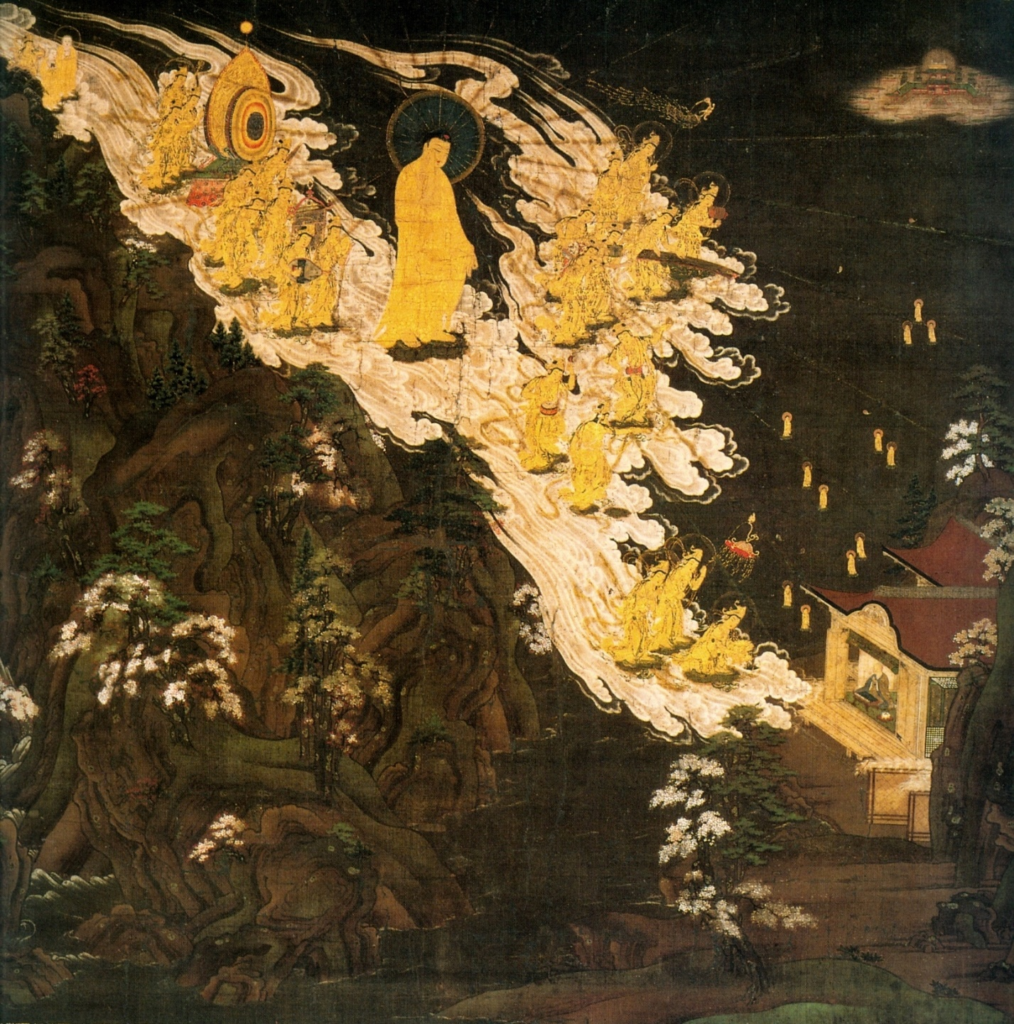
- Please read the following explanation of this painting from the Kyoto National Museum (source: https://www.kyohaku.go.jp/eng/syuzou/meihin/butsuga/item06.html):
"This outstanding work depicts Amida (Amitabha) and twenty-five attendants as they descend on clouds over steep mountains down from Heaven. They are on their way to meet a dead person, depicted in the bottom-right, to accompany back to Heaven. This scene is known as "Rapid Descent," because of the especially swift appearance of the clouds. Flying clouds and the depiction of figures and garments in gold are characteristic of Buddhist paintings in the Late-Kamakura Period.
This scene depicts jo-bon jo-sho (first class, upper birth), the highest state of death, evident from the dead person seated upright in front of a sutra scroll and the pagoda in the sky in the upper-right of the painting. The mountains in the background are high, but their smooth contour lines produce a gentle effect typical of the Yamato-e paintings. Though the scene depicted in this work is imaginary, its elements of landscape expression are impressive."
1.2: The True Essence of the Pure Land Teaching, also known as Shin Buddhism / Jōdo Shinshū (浄土真宗).
- This school was founded by Shinran (親鸞,1173 –1263), a disciple of Hōnen (see above).
- The Jōdo Shū (above) asserts that one can lose the guarantee of rebirth in the Pure Land during one's life.
- However, the Jōdo Shinshū teaches that rebirth is certain after one calls Amida's name with faith, and this faith is itself a gift of Amida.
- Hongan-ji is the name of the largest school of Jōdo Shinshū Pureland Buddhism
  - Hongan-ji was founded in 1321, on the site of Otani Mausoleum, where Shinran’s ashes are kept.
    - Hongan-ji literally means “temple of the original/primal vow”
* The original/primal vow (本願) is the 18th vow made by Amida Buddha in a series of 48 vows in the Infinite Life Sūtra / Longer Sukhāvatīvyūha Sūtra. The text of the 18th vow of Amitabha Buddha, according to Infinite Life Sutra, reads: “If, when I attain Buddhahood, sentient beings in the lands of the ten quarters who sincerely and joyfully entrust themselves to me, desire to be born in my land, and call my Name, even ten times, should not be born there, may I not attain perfect Enlightenment.”
2: Nichiren Buddhism (日蓮宗)
- Also first developed during the Kamakura period (1185-1333).
- Founded by Nichiren (日蓮, 1222 – 1282), a Japanese Buddhist master devoted to the Lotus Sūtra (Sanskrit title: Saddharma Puṇḍarīka Sūtra, literally "Sūtra on the White Lotus of the Sublime Dharma").
- Nichiren regarded the Lotus Sūtra as the ultimate/final teaching of the Buddha and the exclusive means to gain liberation. He interpreted a series of earthquakes, epidemics, and typhoons between 1257-1260 as a result of the popularity of Zen and Pure Land traditions, and argued that these disasters could be averted only by returning to the true faith of the Lotus Sūtra .
- Nichiren taught that people should place their trust in the power of the Lotus Sūtra and express their faith by reciting the “great title” (daimoku 題目), a special/powerful chanted phrase, a mantra, which is: namu myōho renge kyō (南無妙法蓮華経), variously translated as: "I take refuge in the Sūtra of the Lotus of the Wonderful Dharma” or "devotion to the Mystic Law of the Lotus Sūtra," among others.
  - This is a short collection of powerful syllables (known generally as a mantra), similar to the nenbutsu as discussed above. However, Nichiren Buddhism does not use this mantra to seek rebirth in a Pure Land but rather to develop one's Buddha Nature (see Part 7: Buddhist Cosmology and Cosmogony; Introduction to Mahayana Buddhism for a refresher on this concept of Buddha Nature). Although the goals are different from Pure Land Buddhism, the rationale for relying upon the power of a single scripture (albeit a different one) is the same: in the age of the decline of the teachings (see above), practitioners should rely on the powers already embedded in scriptures rather than one's own "self power," a concept antithetical to both early Buddhism as well as other forms of Japanese Buddhism like Zen.
* Let's pause here for a moment to consider what's happening more broadly here in the context of Buddhist thought. Mahāyāna Buddhist scriptures frequently refer to their own powers. Compared to earlier forms of Buddhism, the Mahāyāna tends to highlight the non-intellectual or non-cognitive power of the scriptures. This means that the scriptures are powerful when just heard, held, viewed, or uttered, without needing to necessarily read and understand them. As such, Mahāyāna Buddhism often views scriptures more directly as embodiments/manifestations of the Three Buddha Bodies (that is, the scriptures are themselves conduits of the Buddha's powers, beyond just the meaning of the words that they contain). In East Asian Buddhism, as we're seeing, the path to salvation is sometimes distilled down to a very specific set of scriptures and, even further, to a specific set of words (i.e., a mantra) from those scriptures. The rationale is this: If the Three Buddha Bodies are full of boundless compassion and skillful means, it makes sense (from within the tradition) that scriptures would be as helpful as possible to humans. Short names, titles, and statements (i.e., mantras) like those examined above are therefore the Buddha's power manifested in the easiest possible way for humans to gain salvation.
- A development of Nichiren Buddhism is the lay organization called Soka Gakkai (Value Creation Society), founded in 1937, which became an independent entity in 1992.
Documentary about Soka Gakkai
- Watch this fascinating 1995 documentary about Soka Gakkai: https://www.youtube.com/watch?v=3xasAOg7zag
3: Japanese Vajrayāna Buddhism / Mikkyō (密教, “secret/esoteric teachings”)
3.1: Shingon Buddhism /Shingon-shū (真言宗)
- Shingon is the Japanese pronunciation of the Chinese zhēnyán, meaning mantra (sacred syllables).
- The school was founded by Kūkai (空海), also known as Kōbō-Daishi (弘法大師 The Grand Master Who Propagated the Buddhist Teaching), 774–835.
- Kūkai trained in China under a master named Huiguo (惠果) (746–805) and Kūkai became Huiguo’s successor (the Vajrayana tradition largely died out in China).
- The teachings of Shingon are based on early Buddhist tantras (Vajrayāna literature), for example, the Mahāvairocana Sūtra.
- Main Deity: Vairocana (Dainichi Nyorai 大日如來), who is the basis of all phenomena; i.e., this deity is truth/reality itself. This Buddha is hence known as the “truth body” (dharmakāya). In Shingon Buddhism, the goal is to realize one’s true nature as identical with Vairocana.
- After his death, Kūkai was entombed at Mount Kōya (高野山 Kōya-san), which is the headquarters of Shingon Buddhism.
- According to legend, when his tomb was opened a while after he died, he appeared to be sleeping (with an unchanged complexion and longer hair and nails). He is believed to be in a deep state of meditation awaiting the coming of the future Buddha, Maitreya. The article posted below reads: "In the 11th century a hagiography of Kūkai appeared claiming that, upon his death in 835, the monk did not die at all, but crawled into his tomb and entered nyūjō, a state of meditation so profound that it induces suspended animation. According to this hagiography, Kūkai plans to emerge in approximately 5.67 million years to usher a predetermined number of souls into nirvana."
  - This legend itself is the inspiration for one of the most unusual, yet very rare, Buddhist ascetic practices: self-mummification. Please read this fascinating article on the history of this practice: https://www.atlasobscura.com/articles/sokushinbutsu.
- In most Shingon temples, the goma (護摩), a sacred fire ritual is performed daily. The deity worshiped in this fire ritual is typically Acala (Fudō Myōō 不動明王). The ritual destroys negative/detrimental karma, thoughts, and desires, and also invites requests and provides blessings.
* Although it's sometimes hard to distinguish what constitutes Vajrayāna vs. Mahāyāna Buddhism, mantra (sacred syllables), mudra (gestures), and mandala (diagrams) are three hallmarks of the Vajrayāna. These are considered to be tools of communication through which the dharmakāya (i.e., the truth body; the true nature of existence) communicates.
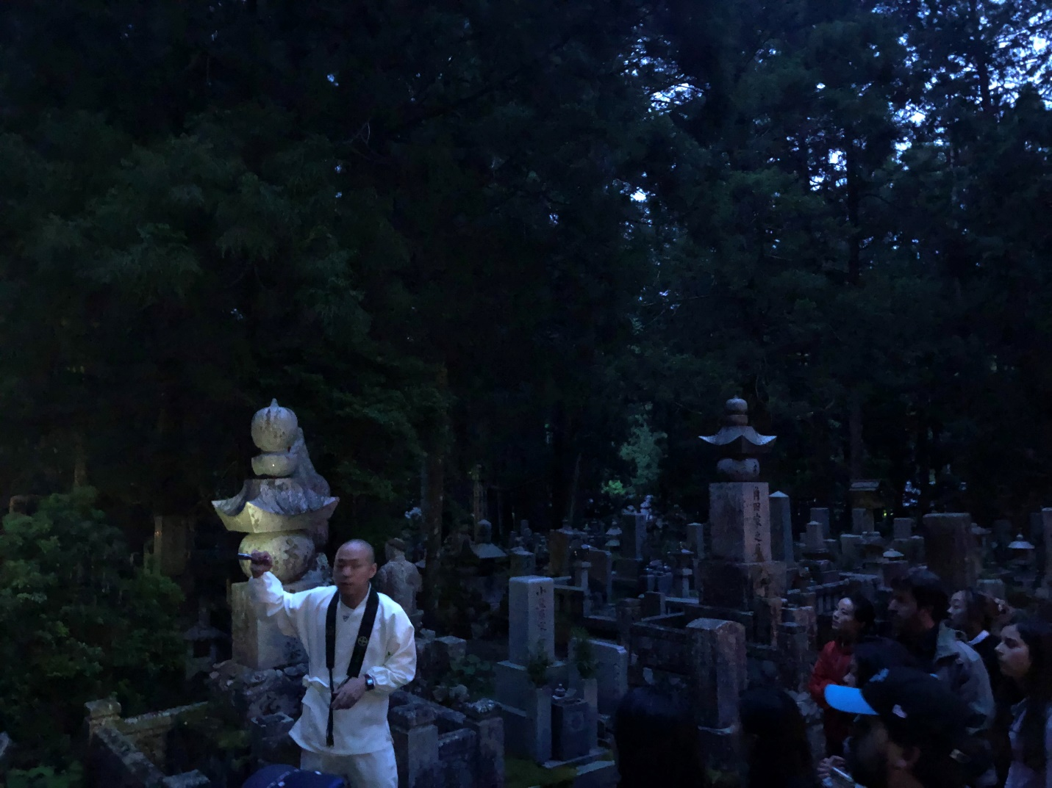
A monk leading a tour at Mount Kōya on the way to Kūkai's tomb (on the Langara 2019 Japan field studies program).
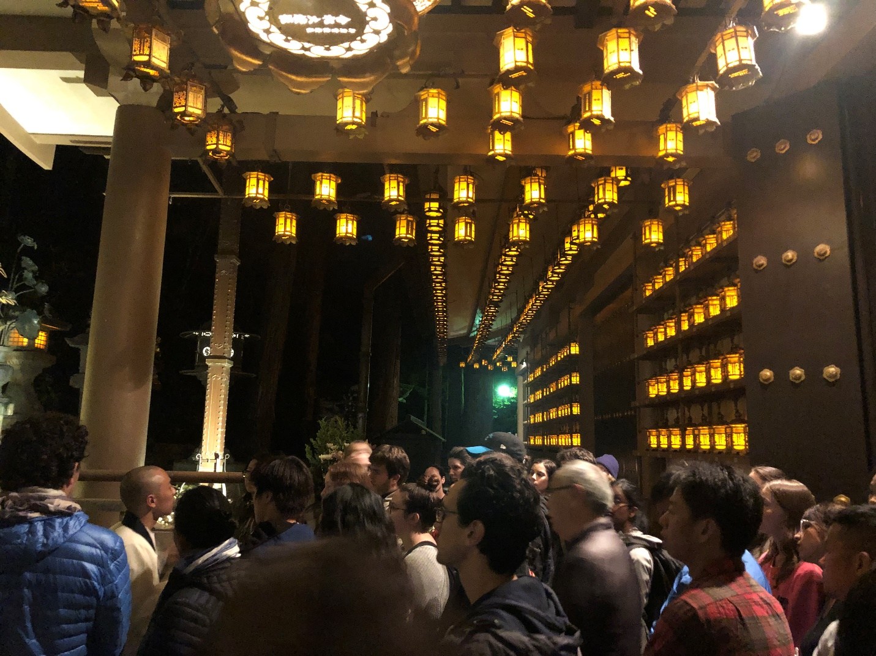
A crowd gathered outside Kūkai's tomb
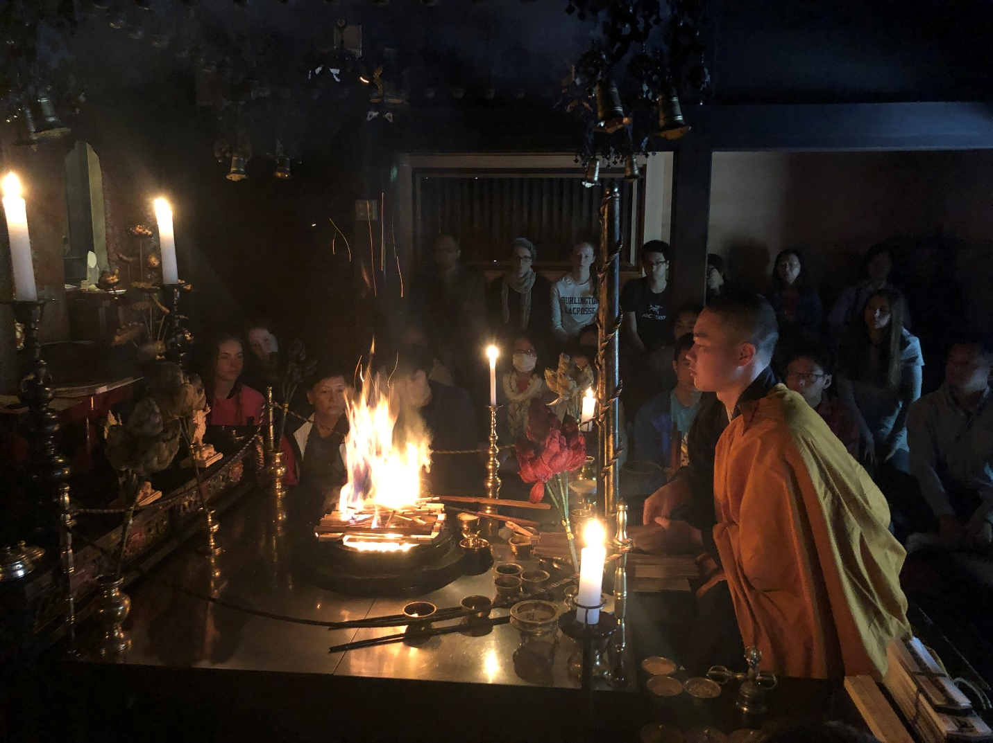
A monk performing the goma ceremony at Mount Kōya (on the Langara 2019 Japan field studies program).
3.2: Tendai Buddhism (天台宗, Tendai-shū)
- Tendai descended from the Chinese Tiantai school (not of Indian origin), yet also blended esoteric Buddhist elements such as mantra, mudra, and mandala (see right above)
- Tendai was founded by Japanese monk Saichō (最澄, 767 – 822), after having brought back teachings from China.
- Like Nichiren Buddhism, this school argues that the Lotus Sūtra constitutes the highest teaching of the Buddha.
- The school emphasizes a wide array of beliefs and practices, which overlap with other Japanese Buddhist traditions:
  - Worship of Amida Buddha
  - Recitation of Amida’s name (i.e., practices to enter the Pure Land – see Pure Land Buddhism above)
  - Various types of meditation, including shikan (止観, “Calming-Insight”) meditation, similar to Zen meditation (see below)
  - An esoteric tradition known as known as tōmitsu (東密), which is similar to Shingon – i.e., using of mantras, mudras, and mandalas.
  - The concept of Buddhahood is being present in all things, similar to beliefs/emphases in Kegon Buddhism (華厳宗, another school, but not explained in this lesson).
  - The school also asserts that kami (nature deities) are embodiments of Buddhahood (therefore absorbing elements of Shinto, Japan's pre-Buddhist religion).
  - Many Buddhas, bodhisattvas, Hindu gods, and Kami are worshipped in Tendai Buddhism.
The kaihōgyō (回峰行) (“circling the mountain”) Tradition
- The kaihōgyō is a fascinating ascetic pilgrimage practice performed by Tendai monks at temple of Enryaku-ji (延暦寺) found on Mt. Hiei, which is Japan's first Tendai monastery founded by Saichō in 788 during the early Heian Period (794-1185)
- This pilgrimage practice is believed to have been founded by Sōō Oshō (831-918), a Tendai monk who spent years performing ascetic practices on Mt Hiei and other nearby mountains.
- There are two kaihōgyō practices:
  - 100 days
  - 1,000 days
    - The ultimate achievement is the completion of the 1,000-day challenge, which would rank among the most demanding physical and mental challenges in the world.
    - Only 46 men have completed the 1,000-day challenge since 1885.
- Tendai Buddhism asserts that awakening can be gained in the current life through selfless service and devotion. The kaihōgyō is seen as the ultimate expression of this. By the end of the practice, monks should form self-identification with a wrathful Buddha known as Acala (Fudō Myō-ō 不動明王), who is also worshiped in Shingon Buddhism.
Documentary on the kaihōgyō:
- https://www.youtube.com/watch?v=M4tcN2YfA-k
  - Sorry about the poor quality; however, this is one of the best documentaries ever produced about a Buddhist practice. It's fascinating!
4. Zen Buddhism / Zen shū (禅宗)
- First entered Japan during the Kamakura period (1185-1333)
- The three traditional schools of Zen in contemporary Japan are:
  - Sōtō school (曹洞宗 Sōtō-shū)
  - Rinzai school (臨済宗 Rinzai-shū)
  - Ōbaku school (黄檗宗 Ōbaku-shū)
- Sōtō is the largest, and Ōbaku the smallest, with Rinzai in the middle.
- The primary goal of Zen is known as kenshō (見性), seeing one's true nature, which is Buddha Nature. In Zen, as well as other forms of Buddhism, this means seeing that there is no "I" or "self" and that our true nature, like all phenomena is merely emptiness (śūnyatā).
- Zen practice involves a seated meditation known as zazen (座禅) meditation, which probes into into the nature of existence.
- Another practice of Rinzai Zen is known as kōan (公案), a paradoxical anecdote or riddle, used in Zen Buddhism to demonstrate the limitations of logical reasoning and to generate insight and awakening. Check out this short explanation here: https://www.youtube.com/watch?v=9p5Oi4wPVVo.
- Sōtō Zen rarely uses of kōan and emphasizes a practice known as "silent illumination" (shikantaza 只管打坐). Unlike other forms of Buddhist meditation, such as mindfulness of breathing, this meditation has no object at all; it is understood as "simply sitting" or "nothing but sitting."
- Watch this very short video about Zen: https://www.youtube.com/watch?v=_WAi2fwUqN4
A few clips/readings about contemporary issues and practices in Japanese Buddhism:
- A good, short clip on the changing nature of Buddhism in Japan: https://www.youtube.com/watch?v=TqbS3lMECYE
- Robot Buddhist statues and priests:
  - One of Japan's Buddhist robots (this one of the Bodhisattva Kannon): https://www.youtube.com/watch?v=_XdQugsDz8E
  - Here's another robot that can perform Buddhist funeral ceremonies: https://www.youtube.com/watch?v=csgzCJC9VL8
- This is a short, yet fascinating article about the emergence of "mindfulness" in Japan: https://tricycle.org/magazine/mindfulness-in-japan/

